**Instructions (What to do and How to do It):**

Based on the github page for MEPS data, the Readme R files, and the R exercise files, apply the methods for Logistic regression to the MEPS dataset.  
The Logistic regression should identify demographic factors associated with binary variable (such as Flu Shot or DR CHECK BLOOD PRESSURE) in 2018 (using methods in Exercise 4 of MEPS). Check the MEPS code book, attached in required resources.

Attach your results in a word document, and your .R file.  
Interpret your results.

After your initial logistic regression, discuss the impacts of application of marginal effects in healthcare data

**Assignment Walk-through**

**Part 1: Review the MEPS website to identify the list of potential variables –**

Click on data files ->full year consolidated files->2018->code book or documentation



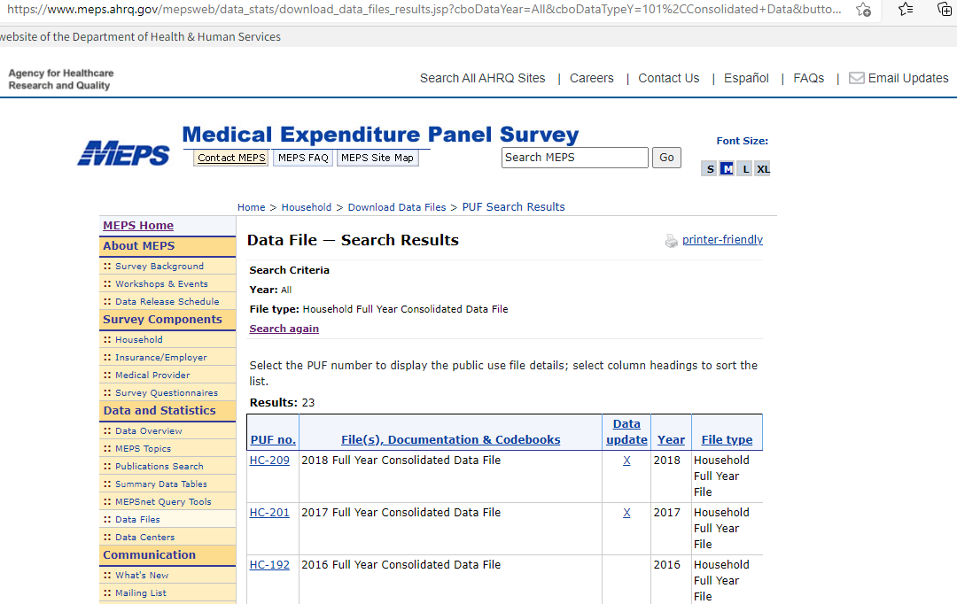

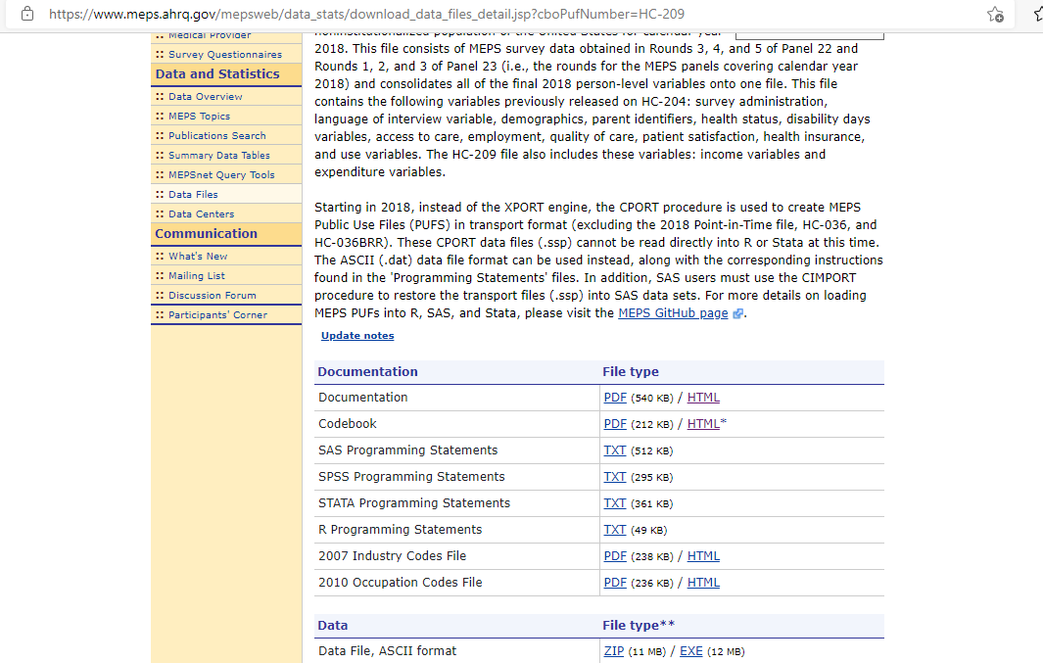

**Part 2: Use the example provided in the MEPS github page (already linked to RStudio cloud), to load the consolidated survey data for the MEPS survey 2018 (5 points)**

Follow along the commented R code; install relevant packages listed in the workshop example 4 (survey, foreign, dplyr, devtools)

Note, in the above picture, there is an ASCII file of the MEPS data; this the file that the MEPS library in R directly imports

**Part 3: Change the dependent variable to a different binary variable, and run a logistic regression using the MEPS workshop 4 example code (10 points)**

**Part 4: Save the .R file (2 points)**

***How do you save a script in RStudio?***

Saving the file

To save the script, you can either click on the blue save icon, use the keyboard commands Ctrl + S on Windows or Command + S on Mac OS or go to File > Save. This file will be open in RStudio the next time you reopen RStudio unless you click on the X on the file tab to close it.

***Note: see the R cheat sheet for R Studio IDE to become familiarwith usage of the IDE and how to download .R files.***

**Part 5: How would you interpret your results, from Part 3? What if marginal effects were applied, how would you interpret results, in that manner? (3 points)**